

Interactive Map of SETU Carlow

Functional Specification

6th December 2024

Supervisor: Dr Oisin Cawley
Student: Gábor Major – C00271548
Table of Contents
Introduction 2
Description 2
Functionality 2
Core Features 2
Non-Core Features 3
Users 3
Target Platforms 3
Context Diagram 4
Use Case Diagram 5
Use Cases 6
Brief Use Cases 6
Detailed Use Cases 7
Use Case: Search Room 7
Use Case: View Campus Map 7
Use Case: View Room Information 7
Use Case: Navigate To Room 8
Use Case: Modify Room Information 8
Use Case: Modify Map Waypoints 9
Metrics 10
Functionality 10
Usability 10
Reliability 10
Performance 10
Supportability 10
Similar Applications 11
References 12

Table of Figures
Figure 1: System Context Diagram 4
Figure 2: Use Case Diagram 5

Introduction
The purpose of this document is to outline the functionality of the Interactive Map of SETU Carlow application.
The document starts off with a short description of the application, then outlines the main functionalities categorising them into core and non-core features. Next the target users and platforms are laid out, the context and use case diagram, and a description of the use cases associated with them. Finally, them metrics of the system according to FURPS is discussed, and some examples of similar applications at the end of the document.

Description
The Interactive Map of SETU (South East Technological University) Carlow is an application for students and lecturers for finding their way around the Carlow campus.
The application allows for searching through rooms of the different buildings, viewing their locations, and other information about the rooms and helps people by by allowing them to navigate to a specific room or place they wish to go to from their starting position, using the route displayed on the screen.

Functionality
The core functionality of the application is very important to work properly, because if someone uses the map and is not able to use it to get around campus or even worse gets further lost then the application would be a failure.
Thus above all else the application needs to be able to properly route from the starting point and the end point and show this route to the user so they can easily follow it and get to their desired destination.
The following are a list of features that are core to the application i.e. without it the application would not be working properly, and another list of non-core features, these being additional functionality that would be good to implement as it helps elevate the user experience of the application.

Core Features
- A collection of rooms and places collected and labelled with information, example location, room number, room name, usage description.
- Display a map of the campus with the rooms available to be accessed.
- Search through the rooms available and application shows the information and location of room.
- Using selected start and target position the application shows the best route to take.
- Pathfinding takes into account the multiple floors of the buildings.
- An Admin login for editing the existing room data available.

Non-Core Features
- Application shows a selection of potential paths for the user to take.
- Using GPS coordinates for rooms and waypoints.
- Usage of Android Geolocation API to give real-time feedback to the user on their location along the path.
- Allow the flagging of certain routes as closed, and pathfinding accommodates for route changes
- 3D rendering of campus buildings and rooms in their correct locations.
- Limiting variables may be taken into account for the user, for example if a wheelchair user, use the elevator instead of the stairs for pathfinding.
- Editable map of rooms’ locations and buildings’ shapes.

Users
- First, the primary target audience of the application would be new people coming into the campus. This would include new students, new lecturers. Getting used to the location of buildings and rooms can take a few weeks and the application would help speed up this process.
- Second, any guests visiting the campus would greatly appreciate if there was a map of the campus available as they may only be visiting temporarily and do not have the time to learn the layout of the campus.
- Third, the application would also be of great help to the peer mentors as they get a lot of questions every year from first years on where the buildings are or where specific rooms are located. They would be able to show and help them using the map.

Target Platforms
The primary platform for this system is to have an Android mobile map application that would be downloadable for any of the target audience wishing to use the map. The advantage of having a downloadable mobile application is that it would work even without internet connection throughout the whole campus.
The secondary platform would be a web application that the users would be able to use from any device and any operating system as they only need a web browser to access it. This would allow non Android phone users to also be able to use the map.

Context Diagram
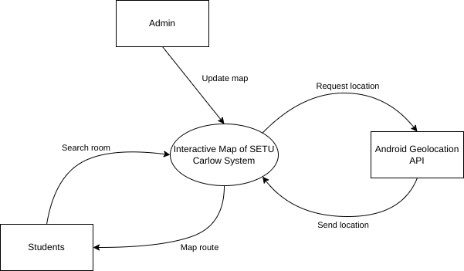Figure 1: System Context Diagram

Use Case Diagram
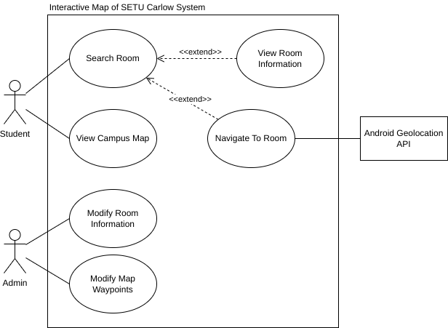Figure 2: Use Case Diagram

Use Cases

Brief Use Cases
- Use Case: Search Room
Actors: Student
Description: This use case allows the student to search through the whole list of available rooms. The student starts typing into a search box and potential results are listed.
- Use Case: View Campus Map
Actors: Student
Description: This use case allows the student to view the map of the campus, the rooms and buildings and to move the map around freely.
- Use Case: View Room Information
Actors: Student
Description: This use case is used after the student has searched for a room and selected it for further information viewing. The full list of information about a room such as its number and description are displayed to the student.
- Use Case: Navigate To Room
Actors: Student, Android Geolocation API
Description: This use case is used after the student has searched for a room. The student is then able to select the room as the target destination for the navigation getting back a map route.
The starting location can either be a position selected by the student or the location of the student’s phone which is queried from the Android Geolocation API.
- Use Case: Modify Room Information
Actors: Admin
Description: This use case allows the admin to view and change any of the information for a given room, including its room number and description.
- Use Case: Modify Map Waypoints
Actors: Admin
Description: This use case allows the admin to change and move the waypoints on the map according to any structural changes in real life to the campus or its buildings.

Detailed Use Cases

Use Case: Search Room
Actors: Student
Brief Description: This use case starts when the student wants to search for a room.
Main Success Scenario:
    - Student selects the search box.
    - Student starts typing in room name or number.
    - Series of potential results show up for the student to select.
Alternatives:
3a. No results found.
      - Output says no room found.

Use Case: View Campus Map
Actors: Student
Brief Description: This use case starts when the student opens up the application.
Main Success Scenario:
    - Student opens application.
    - Campus map opens up on screen.
    - Student able to move map around, and zoom in and out to view campus.

Use Case: View Room Information
Actors: Student
Brief Description: This use case starts when the student selects a room for viewing more information on it.
Main Success Scenario:
    - Student finds desired room using search.
    - Student selects room for more detailed view.
    - Detailed information about the room such as room description is displayed.

Use Case: Navigate To Room
Actors: Student, Android API
Brief Description: This use case starts when the student selects a room as a destination to get to.
Main Success Scenario:
    - Student finds desired room using search.
    - Student selects room as a destination.
    - Student selects a position as a starting location.
    - Application calculates the shortest path from starting location to the destination.
    - Route is shown to the student on screen.
Alternatives:
3a. Student uses GPS location of phone as starting point.
      - Application calculates the shortest path from phone location to the destination.
      - Route is shown to the student on screen.
4a. No valid route found between the two locations.
      - No valid route shown on screen.

Use Case: Modify Room Information
Actors: Admin
Brief Description: This use case starts when the admin selects one of the rooms available for editing.
Main Success Scenario:
    - Admin selects a room for editing.
    - Admin changes some values of the room.
    - Admin selects save, and the room values are updated on the map.
Alternatives:
3a. Room number already in use.
      - Show that room number are unique and it is already being used by another room.

Use Case: Modify Map Waypoints
Actors: Admin
Brief Description: This use case starts when the admin selects one of the waypoints available for editing.
Main Success Scenario:
    - Admin selects a waypoint for editing.
    - Admin changes some values of the waypoint.
    - Admin selects save, and the waypoint values are updated on the map.

Metrics

Functionality
- User able to select start and end point and route shown according to pathfinding.
- User able to search through all possible locations.
- User able to see detailed information about a specific location, such as room name and description.
- User able to see whole map of Carlow campus of all buildings and rooms.
- Application able to update map data from remote server.

Usability
- UI must be easy to use without any explanations or tutorials.
- Visual feedback such as a loading icon must be shown when doing processing such as the pathfinding or searching.
- Moving the map around on screen must be smooth.
- Text information displayed must have high contrast against its background for better readability.

Reliability
- The application must be able to work offline.
- The application must display waypoints correctly according to the positioning system.
- The start and end point of the route must be saved in case the application is closed.

Performance
- The start-up time of the application must not be more than 3 seconds.
- The searching functionality must show a result in 2-3 seconds.
- Pathfinding from start to end point must take no more than 5 seconds.

Supportability
- Location and description of waypoints and rooms must be editable.
- The extension of new waypoints and rooms must not need changes to the underlying pathfinding algorithm to work.

Similar Applications
Mapping applications are now very common for example Google Maps, Bing Maps, Apple Maps or OpenStreetMap, they are all aimed at mapping the whole world and navigating around on larger scales. These maps are good at getting to SETU Carlow from another location, however they are not very good at getting around the campus itself as they lack the necessary information about the room layouts of the buildings.
Two other similar applications are the Penn State Behrend Campus Map, which is a well made application for the large campus that they have showing all of the different buildings locations and the Interactive Map of Institute of Technology Carlow, which again only showed the buildings names and locations.
This application differs from all of the above named other applications in that it shows the internal layout of the buildings, and has all the necessary information about the rooms’ names and locations to give an accurate and helpful guiding route not just between buildings but also through the buildings.

References
Google (2024) Google Maps. Available at: https://maps.google.com/ (Accessed: 9 October 2024)
Microsoft (2024) Bing Maps. Available at: https://www.bing.com/maps/ (Accessed: 9 October 2024)
Apple (2024) Apple Maps. Available at: https://www.apple.com/maps/ (Accessed: 9 October 2024)
OpenStreetMap Foundation (2024) OpenStreetMap. Available at: https://www.openstreetmap.org/ (Accessed: 9 October 2024)
Penn State Behrend (2024) Penn State Behren Campus Map. Available at: https://behrend.psu.edu/map (Accessed: 9 October 2024)
IT Carlow (2021) Interactive Map of Institute of Technology Carlow. Archive available at: https://web.archive.org/web/20211001235448if_/https://www.itcarlow.ie/interactive-campus-map/ (Accessed 9 October 2024)

